BULIDING A FACE DETECTION AWS APP

Screenshots of AWS:

* AWS login page
* EC2 dashboard
* S3 dashboard
* Rekognition dashboard

Aws login page:



EC2 dashboard:

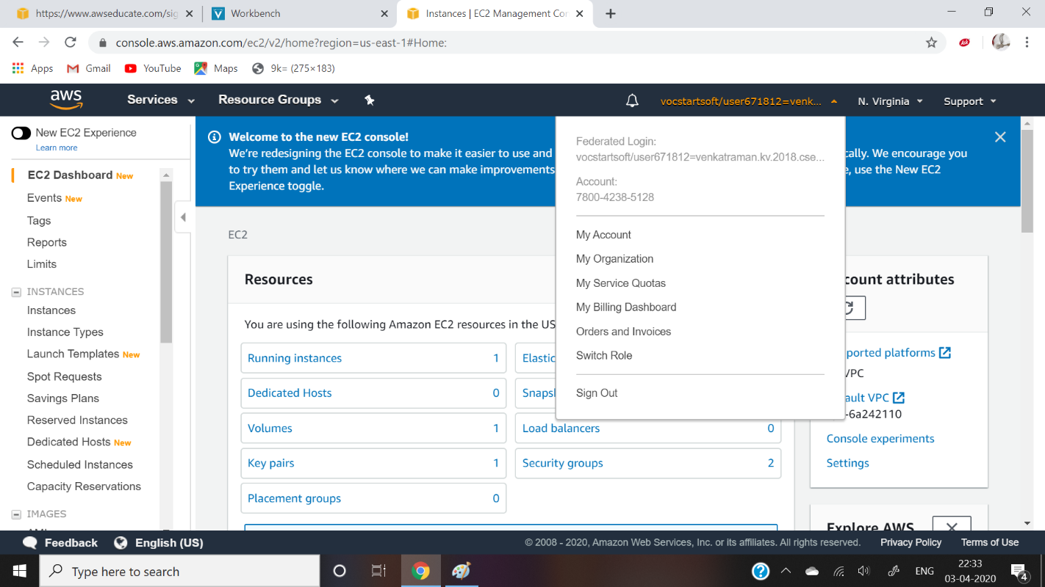

S3 dashboard:

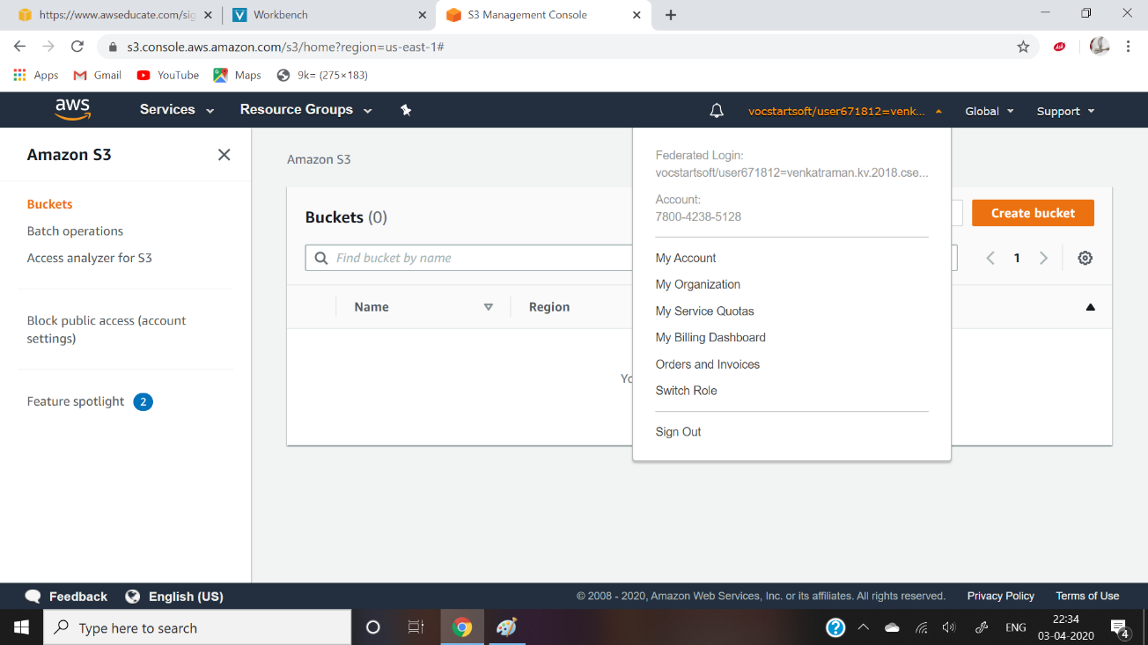

Rekognition dashboard: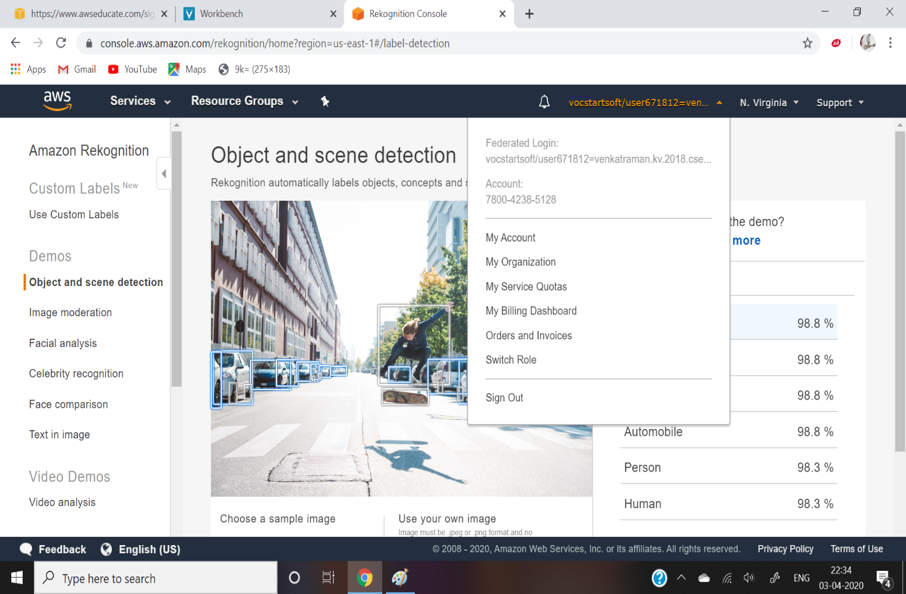

Screenshots Ec2:

* Choosing a AMI
* Choosing a instance type
* Adding storage
* Configuring a security group
* Keypair download
* Conversion of .pem to .ppk
* Logged in EC2 black screen

Screenshots of EC2:

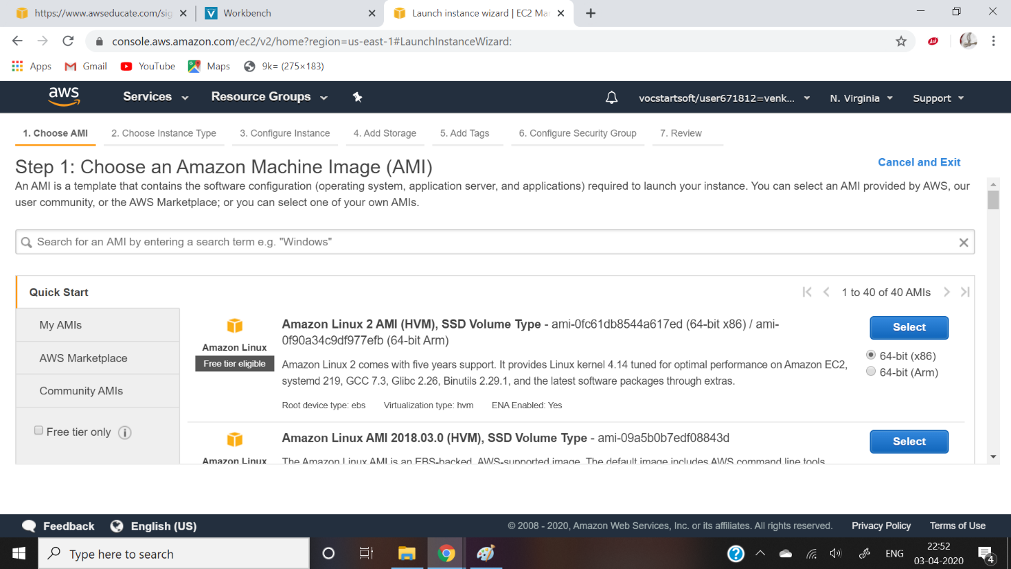

Choosing a instance type:

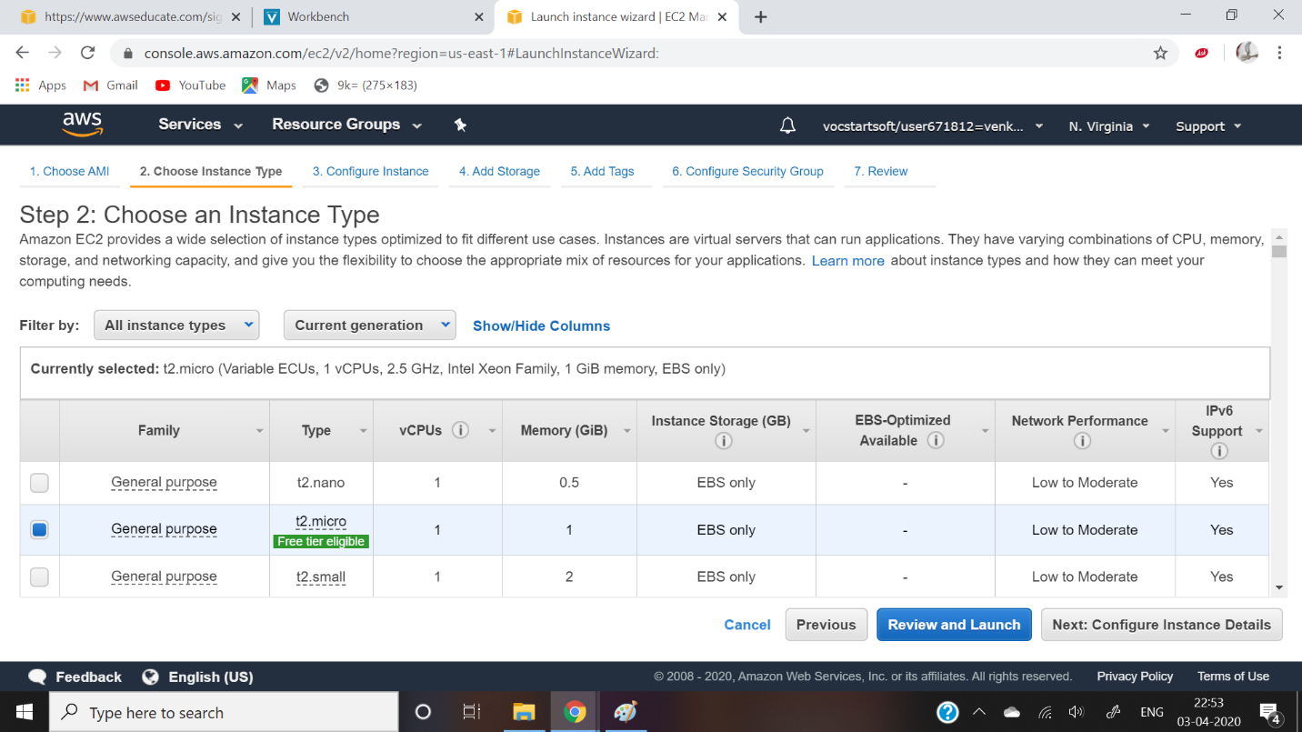

Adding storage:

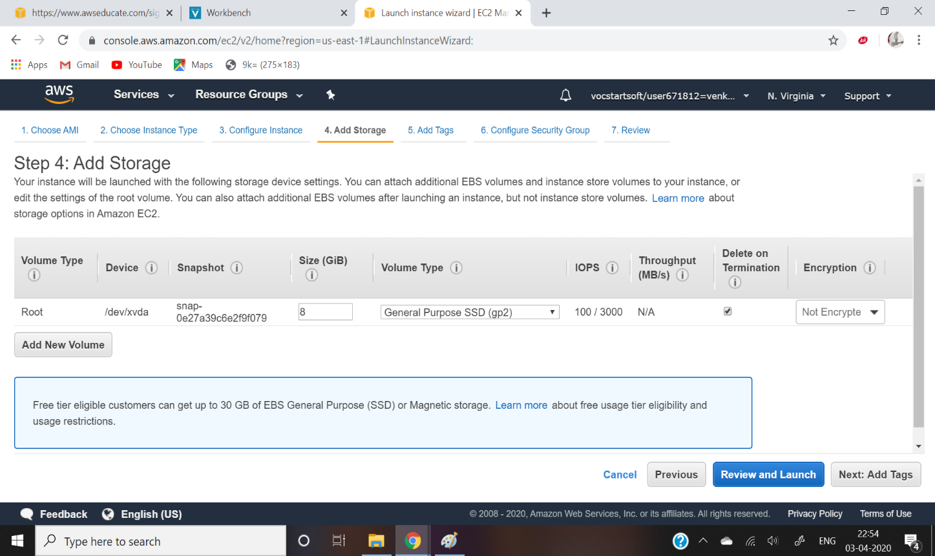

Configuring security group:

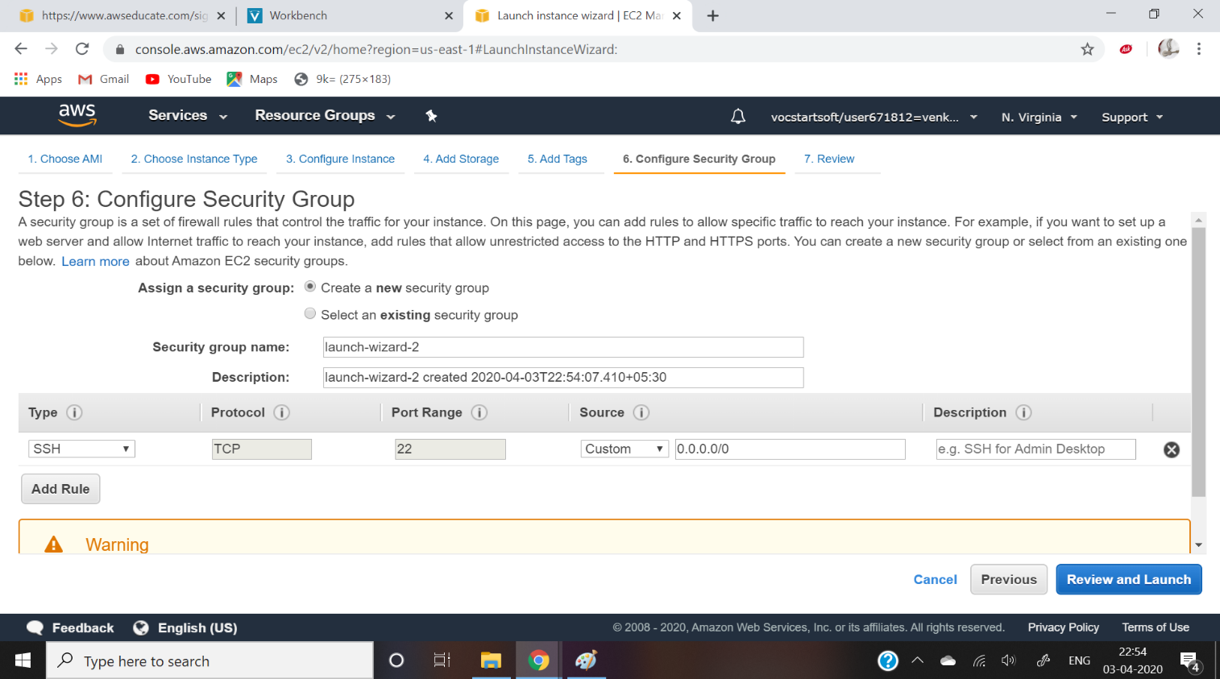

Key pair download:

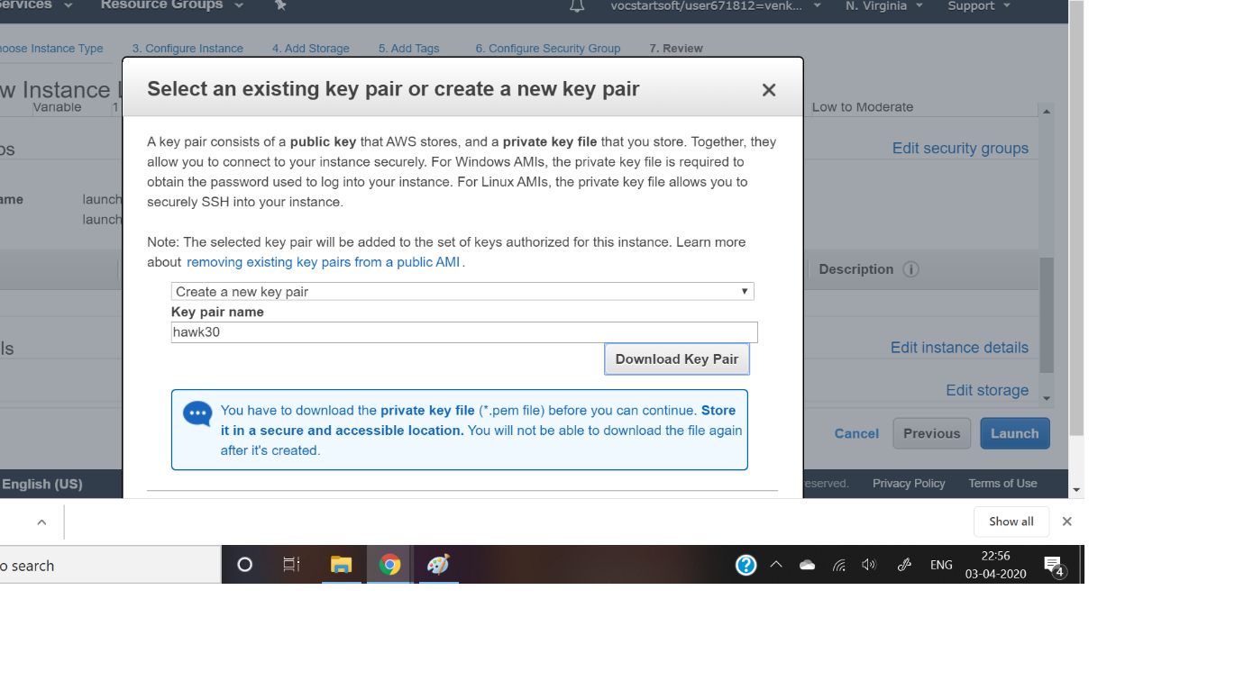

puTTygen conversion of .pem to .ppk

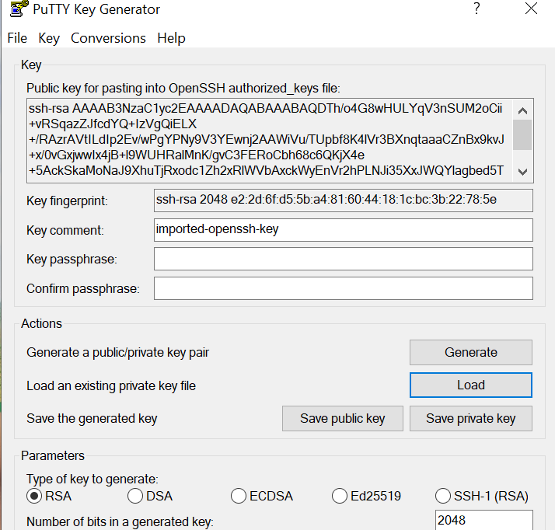 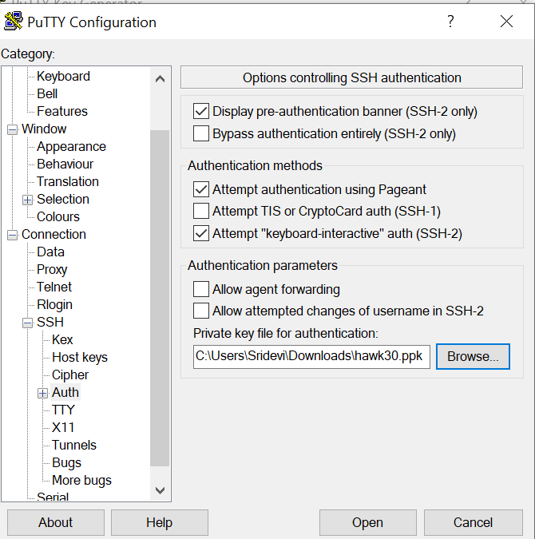

Login blackscreen of EC2:

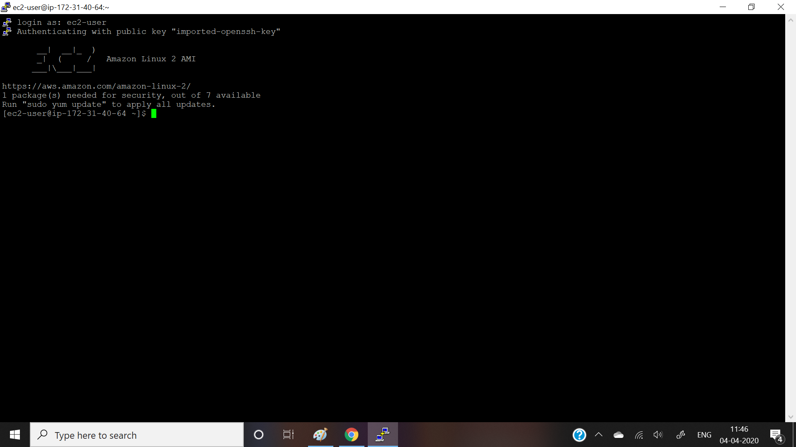

Screenshots of S3:

* Create bucket
* Uploading an object
* Enabling static website
* Making object as public
* Checking the s3link on browser

Create bucket:

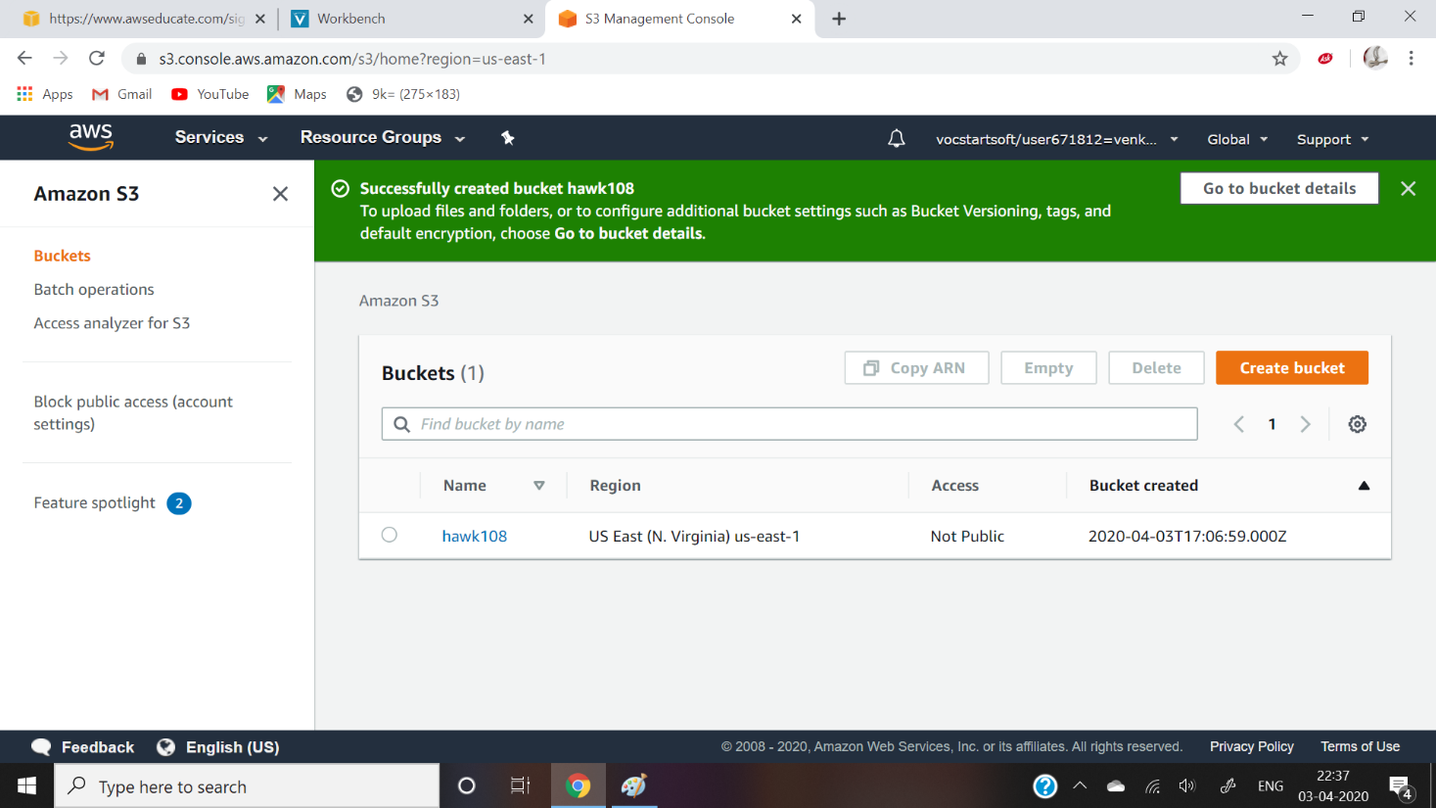

Uploading object:

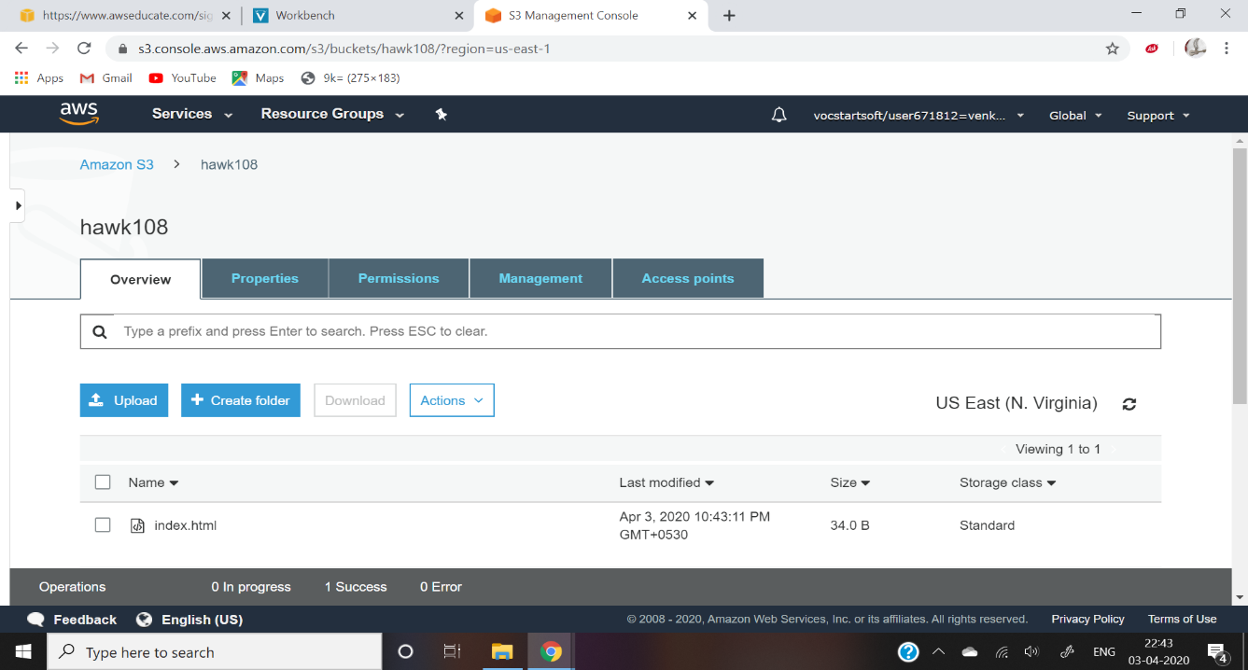

Enabling static website:

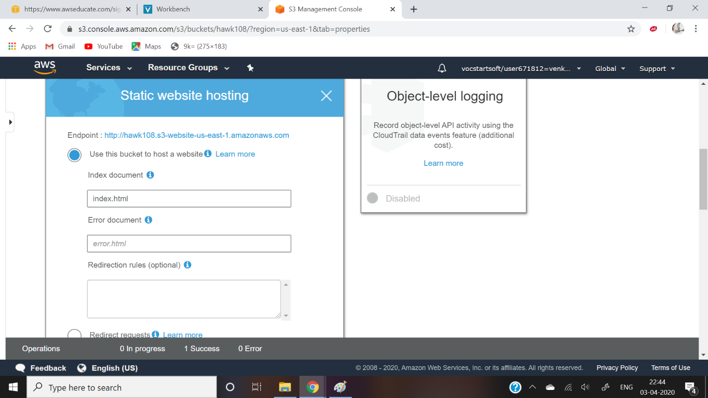

Making object as public

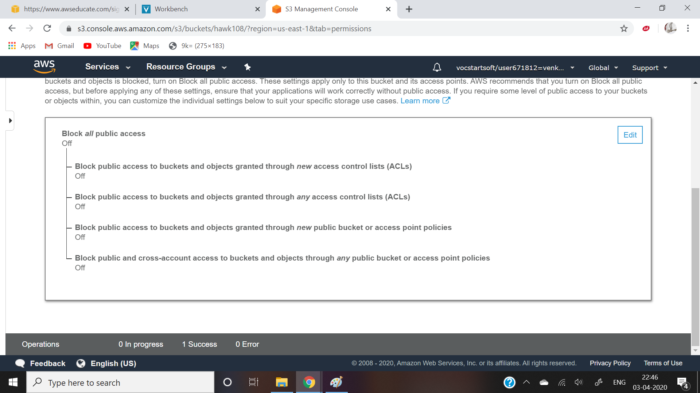

Checking the S3 link :



Rekognition:

* Face detection
* Face compare
* Celebrity rekognition
* Text in image

Face detection:

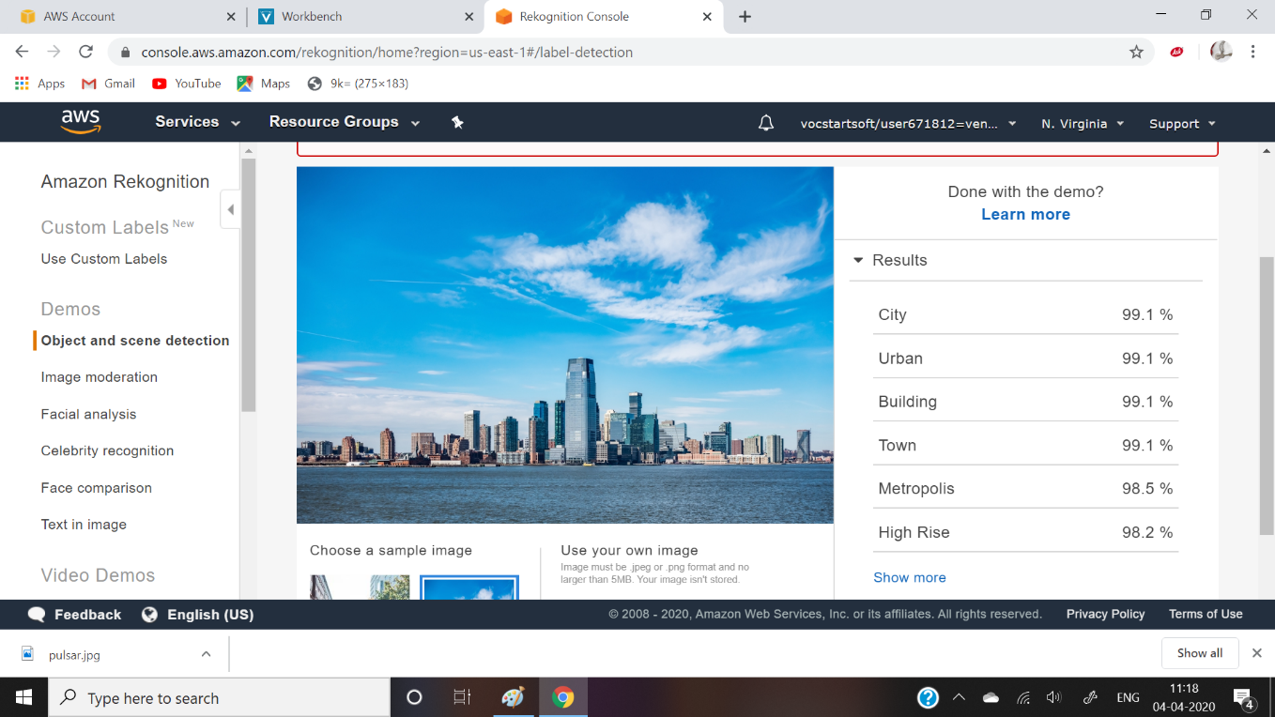

Face compare:



Celebrity reokgnition:

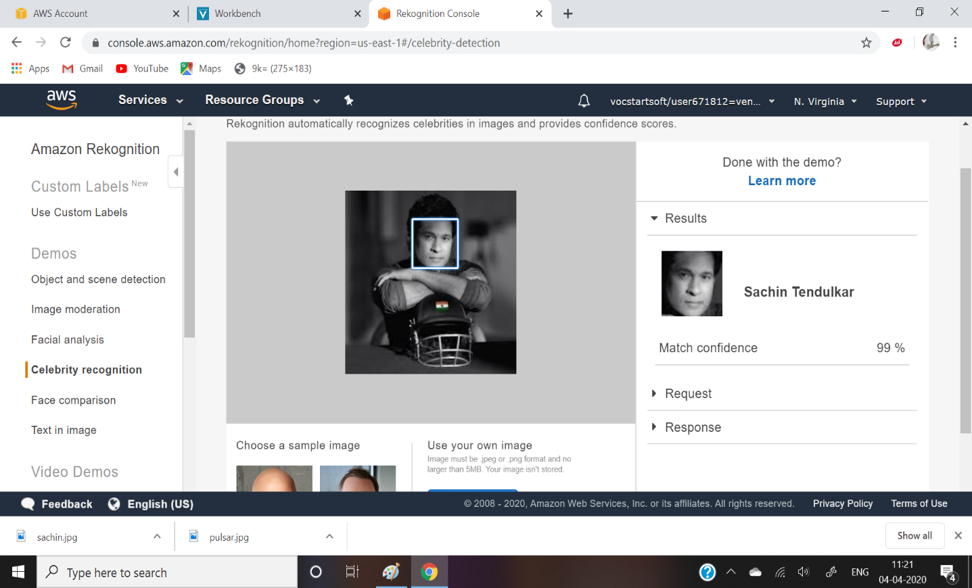

Text in image:



Screenshots of EC2-S3:

* Installing aws.sdk
* Installing php
* Index .php file code
* Upload success

Installing aws.sdk:

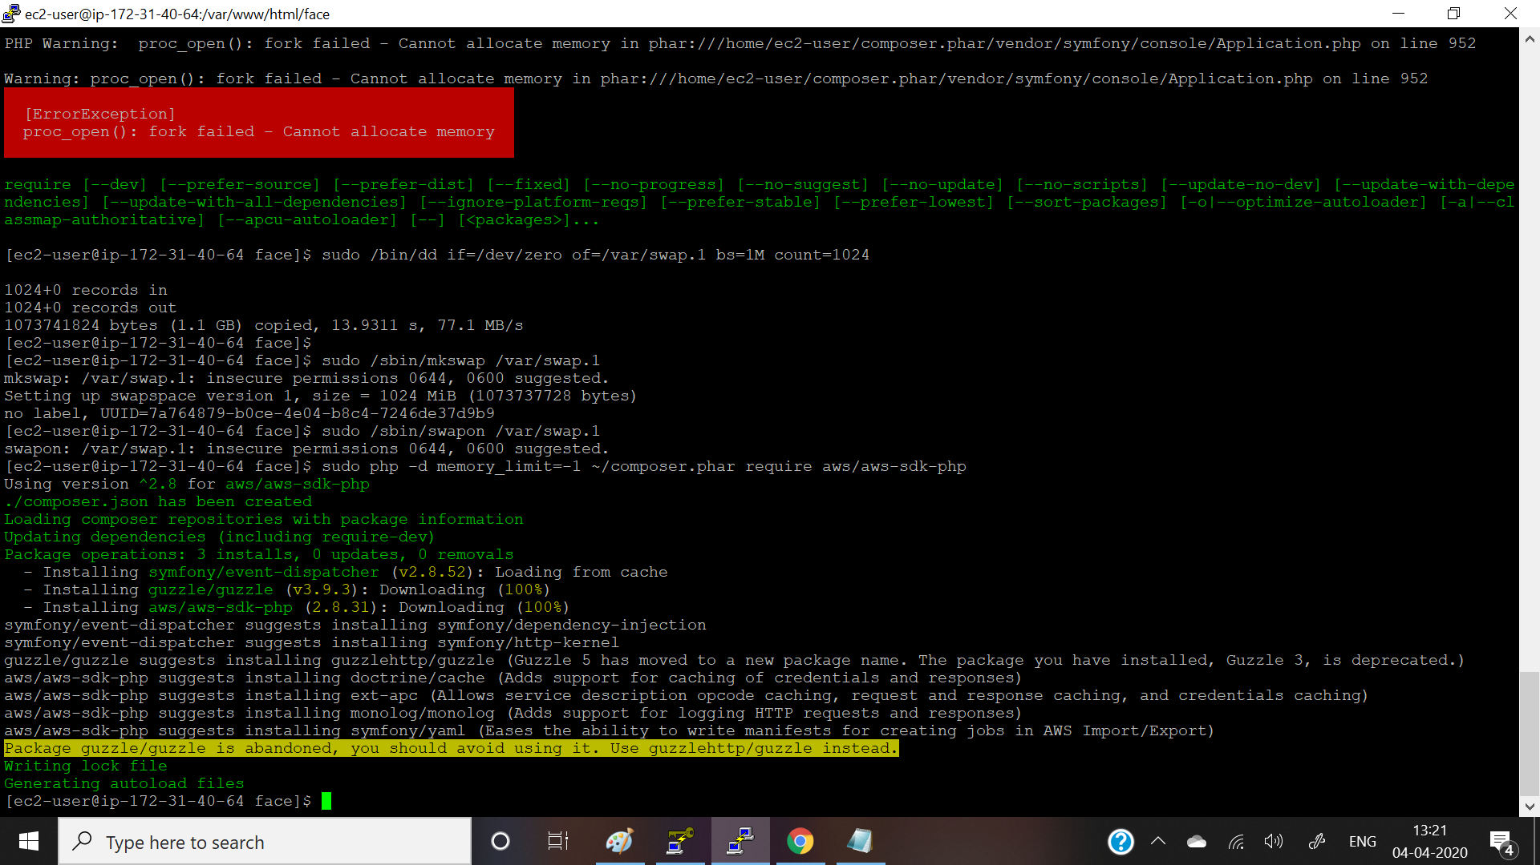

Installing php: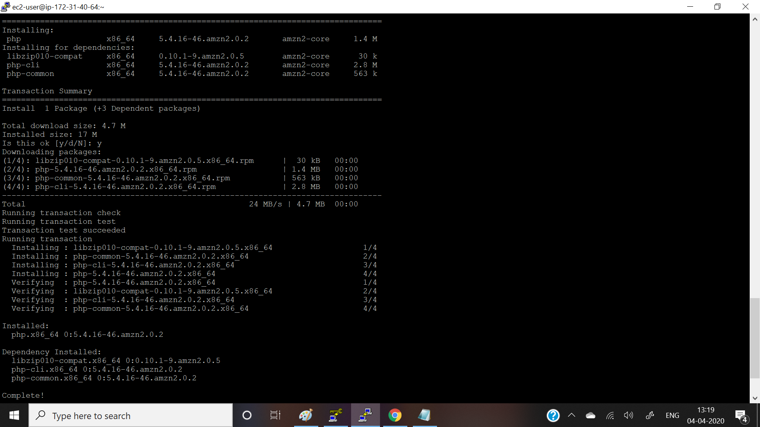

Upload success screenshots:

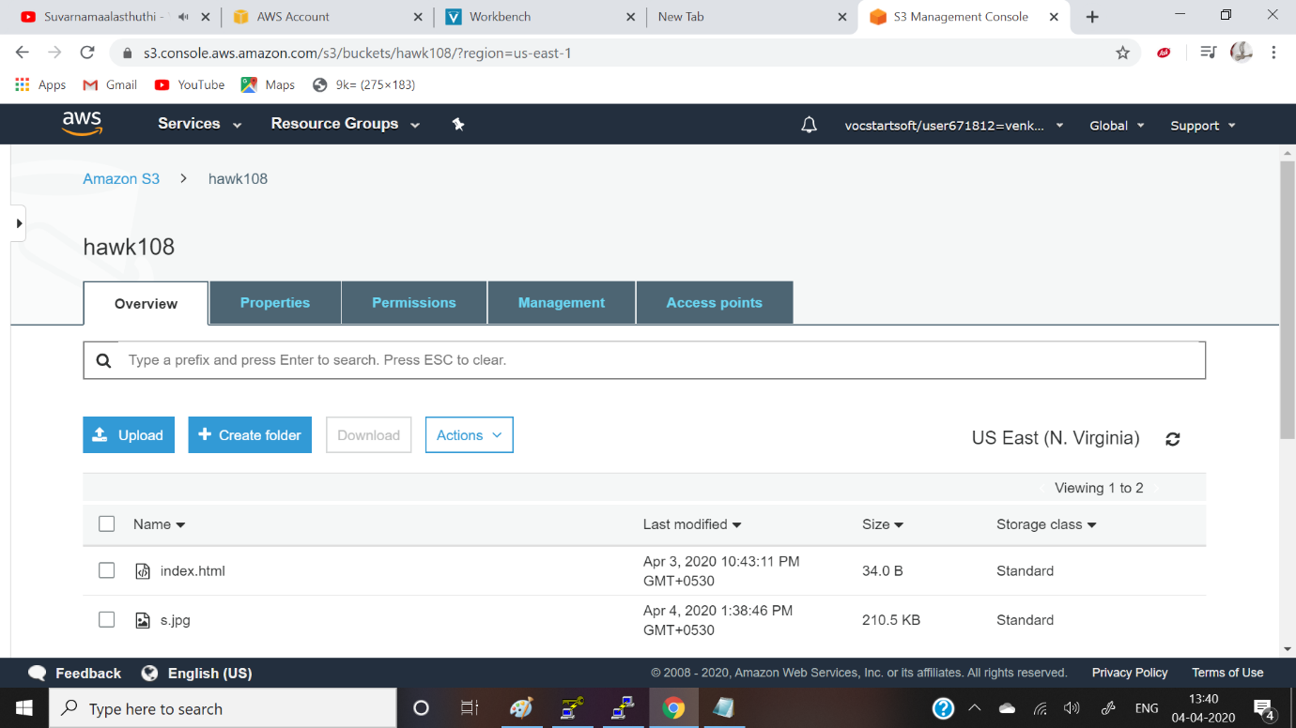



Ec2 and recognition:

